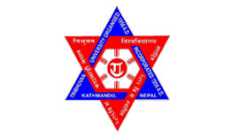
Tribhuvan University
Institute of Science and Technology

PROJECT ON
ON
“CONNECT D-MB”:
A COMMNUCATING PLATFORM FOR BLIND AND DEAF-MUTE

Submitted to:
Department of Computer Science and Information Technology

National College of Computer Studies
In partial fulfillment of the requirements of Final Year, 7th Semester for the bachelor’s degree in computer science and information technology

Submitted By:
Shivesh Shrestha (79010748)

Under Supervision of:
Mr.Radha Krishna Gajurel

CERTIFICATE OF DECLEARATION

Award Title: BSc. Computer Science and Information Technology
Declaration Sheet
(Presented in partial fulfillment of the assessment requirements for the above award)
This work or any part thereof has not previously been presented in any form to the University or to any other institutional body whether for assessment or for other purposes. We confirm that the intellectual content of the work is the result of our own efforts and of no other person.
It is acknowledged that the author of any project work shall own the copyright. However, by submitting such copyright work for assessment, the author grants the University a perpetual royalty-free license to do all or any of those things referred to in section 16(I) of the Copyright Designs and Patents Act 1988. (viz. to copy work; to issue copies to the public; to perform or show or play the work in public; to broadcast the work or to make an adaptation of the work).

Declared By:
Shivesh Shrestha
(5-2-551-35-2022)


Tribhuvan University
Institute of Science and Technology
National College of Computer Studies

SUPERVISOR’S RECOMMENDATION

I hereby recommend that this project, prepared under my supervision entitled “Connect B-DM”, a platform that makes communication between blind person and deaf-mute person possible, in partial fulfillment of the requirements for the degree of B.Sc. in Computer Science and Information Technology is processed for the evaluation.

-------------------------------------
Mr.Radha Krishna Gajurel
Project Supervisor
National College of Computer Studies
Paknajol, Kathmandu

CERTIFICATE OF APPROVAL
This is to certify that the project report entitled “Connect B-DM” is a Bonafede report of the work carried out by Shivesh Shrestha under the guidance and supervision for the degree of B.Sc. in Computer Science and Information Technology at National College of Computer Studies, Tribhuvan University.
To the best of my knowledge and belief, this work embodies the work of candidates, has duly been completed, fulfills the requirement of the ordinance relating to the bachelor’s degree of the university and is up to the standard in respect of content, presentation, and language for being referred to the examiner.
......................................  Mr. Radha Krishna Gajurel  Project Supervisor  National College of Computer Studies | ......................................  Mr. Rajan Paudel  Program Coordinator  National College of Computer Studies
......................................  External Examiner  Tribhuvan University | ......................................  Internal Examiner  National College of Computer Studies

ACKNOWLEDGEMENT

I am sincerely grateful to my project supervisor, Mr. Radha Krishna Gajurel, for his guidance, technical advice, and encouragement throughout this project, especially in navigating the challenges of communication between blind and deaf-mute people. I also thank the National College of Computer Studies (NCCS) and the Department of Computer Science and Information Technology, Tribhuvan University (TU), for providing the resources and academic support needed for this research. Lastly, I deeply appreciate my family and friends for their constant support and motivation during the long hours of coding, testing, and documenting this Connect B-DM project.
Shivesh Shrestha
(5-2-551-35-2022)

ABSTRACT

Effective communication between individuals with sensory impairments, particularly blind and deaf-mute users, is a significant challenge due to the lack of a common interaction medium. This project presents a Python-based assistive system that enables real-time two-way communication by converting gestures, text, and voice across multiple modalities. Deaf-mute users communicate through hand gestures or typing, which are recognized using CNN and KNN models and converted into voice for blind users. Conversely, blind users provide voice input, which is transformed into text and gesture representations for the deaf-mute users. The system integrates speech processing, gesture recognition, and interactive GUI, ensuring accuracy, responsiveness, and usability. Extensive testing at units, integration, and system levels demonstrates the reliability and effectiveness of the solution, offering a practical tool to bridge communication gaps and enhance accessibility for individuals with sensory impairments.

TABLE OF CONTENTS
CERTIFICATE OF DECLEARATION II
SUPERVISOR’S RECOMMENDATION III
CERTIFICATE OF APPROVAL IV
ACKNOWLEDGEMENT V
ABSTRACT VI
TABLE OF CONTENTS VII
LIST OF ABBREVATIONS: IX
LIST OF FIGURES X
LIST OF TABLES XI
CHAPTER 1: INTROUDUCTION 1
1.1 Introduction 1
1.2 Problem Statement 1
1.3 Objectives of the Project 1
1.4 Scope and Limitation of the Project 1
1.4.1 Scope 1
1.4.2 Limitations 2
1.4.3 Development Methodologies 2
CHAPTER 2: BACKGROUND STUDY 3
2.1 Background Study 3
2.2 Literature Review 3
CHAPTER 3: SYSTEM ANALYSIS AND DESIGN 4
3.1 System analysis 4
3.1.1 Functional Requirements 4
3.1.2 Non-Functional Requirements 6
3.1.3 Feasibility Analysis 6
3.1.4 Analysis 8
CHAPTER 4: SYSTEM DESIGN 9
4.1 Algorithm Details 9
CHAPTER 5: IMPLEMENTATION AND TESTING 13
5.1 Implementation 13
5.1.1 Tools Used 13
5.1.2 Implementation Details of Modules 13
5.2 Testing 14
5.3 Result Analysis 15
CHAPTER 6: CONCLUSION AND RECOMMENDATIONS 18
6.1 Conclusion 18
6.2 Future Recommendations 18
REFERENCES 19

LIST OF ABBREVATIONS:

TTS: Text to Speech
SST: Speech to Text
KNN: K-Nearest Neighbor
CNN: Convolution Neural Network

LIST OF FIGURES
Figure 1: Waterfall Model for Connect B-DM 2
Figure 2: Use case diagram for Connect B-DM 5
Figure 3: Level 0 DFD of Connect B-DM 8
Figure 4: Level 1 DFD of Connect B-DM 8
Figure 5: Main GUI Screen 15
Figure 6: Deaf and Mute Mode 16
Figure 7: Send Message 16
Figure 8: Interpret Text 17
Figure 9: Blind Man's Voice Interface 17

LIST OF TABLES

Table 1: Project Schedule Chart of Connect B-DM 7

INTROUDUCTION

Introduction
Communication is a basic human need, but for individuals who are blind or deaf-mute, interacting with others can be extremely challenging, especially when a blind person and a deaf-mute person need to communicate with each other. This project presents a Python-based communication system that acts as a two-way bridge between them. A deaf-mute user can communicate through gestures or text, which the system converts into speech for the blind user, while the blind user responds through voice input that is transformed into text and gesture representations. By combining speech recognition, text-to-speech, and gesture display into one platform, the system helps reduce communication barriers and promotes more inclusive and independent interaction.

Problem Statement
Communication between blind and deaf-mute individuals can be very difficult because they do not share a common, accessible way to interact. Since one relies mainly on hearing and the other on sight, traditional communication methods often do not work. An integrated solution is required that can convert gestures or text into speech for blind users, and at the same time transform spoken voice into text and gesture forms for deaf-mute users, allowing clear and effective two-way communication.

Objectives of the Project
The main objective of this project is to provide an integrated system to make communication between blind man and deaf-mute man possible.

Scope and Limitation of the Project
    - Scope
- Enables two-way communication between blind and deaf-mute users through voice, text, and gesture conversion.
- Supports real-time conversion of gestures/text to speech and speech to text with gesture display.
- Displays output for deaf-mute users in both full text and letter-by-letter gesture format.
    - Limitations
- More natural way to convey the message from blind man to deaf-mute man could be considered.
- Voice may not properly be recognized in case of noisy environment when blind man tries to send message.
- Hand gestures may not be properly identified, like in low light environment.
    - Development Methodologies
Waterfall model is used for this project as requirement is fixed.
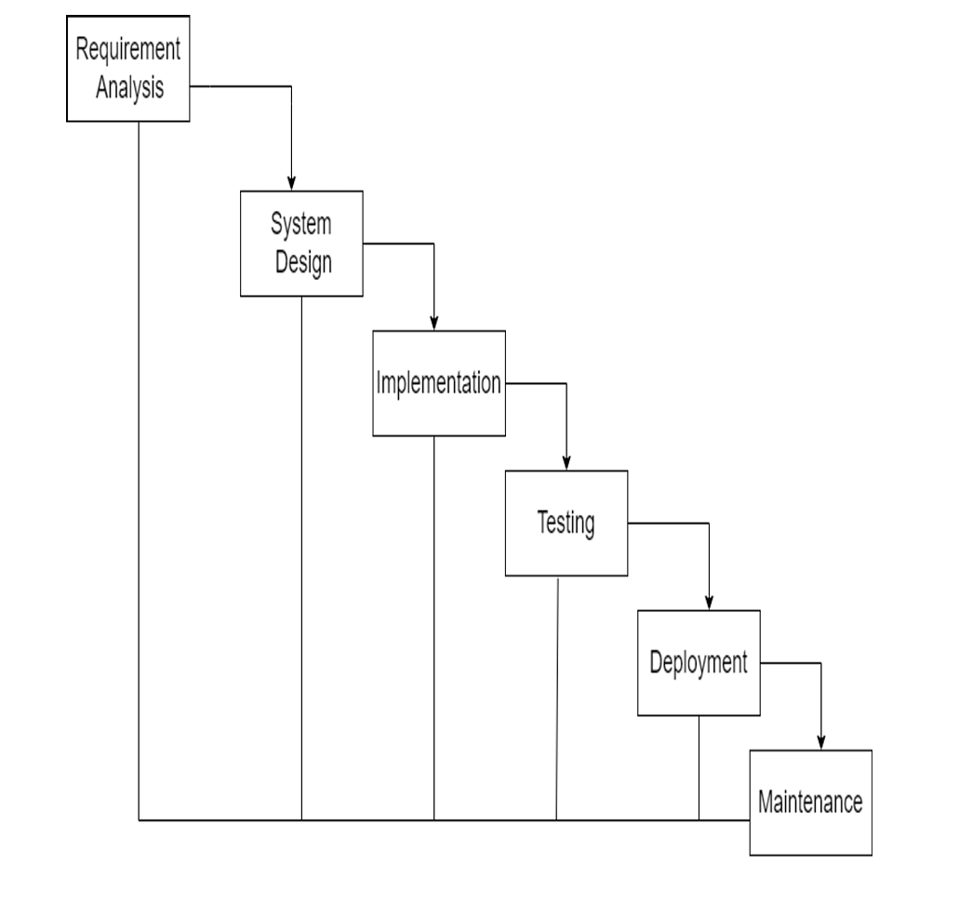
Figure 1: Waterfall Model for Connect B-DM

BACKGROUND STUDY

Background Study
Although technology has greatly improved accessibility for people with disabilities, communication between blind and deaf-mute individuals remains a major challenge because they rely on different modes of interaction—audio for blind users and visual methods like text or gestures for deaf-mute users. To address this gap, modern technologies such as speech recognition, text-to-speech synthesis, and gesture interpretation can be combined into a single integrated system. Using Python, powerful algorithms to recognize hand gesture and also to compare them in term of their accuracy, models like Convolutional Neural Network (CNN), KNN (K Nearest Neighbor), Decision Tree have been used and some libraries for audio processing especially for TTS (Text To Speech), SST(Speech To Text), this project develops a solution that converts voice, text, and gestures into accessible formats, enabling smooth and effective two-way communication between blind and deaf-mute individuals.

Literature Review
Hand gesture recognition plays an important role in assistive communication systems by converting sign gestures into text and speech outputs. The paper “Hand Gesture Detection and Conversion to Speech and Text” (2018) presents a vision-based approach that uses image processing techniques such as contour detection to recognize hand gestures and translate them into audio and text. Compared to sensor-based glove systems, this method reduces hardware complexity and improves usability [1].
The paper “Mediapipe and CNNs for Real-Time ASL Gesture Recognition” (2023) proposes a real-time computer vision system that integrates MediaPipe hand-landmark extraction with a Convolutional Neural Network (CNN) to recognize American Sign Language (ASL) alphabets with high accuracy. Using MediaPipe for efficient feature extraction and CNNs for classification, the system demonstrates the ability to detect static sign gestures in real time, offering improved performance for assistive communication tools for the hearing-impaired. Its results suggest that the combined use of lightweight hand tracking and deep learning can provide robust and practical sign language recognition solutions [2].
The paper “Speech/Text to Indian Sign Language Using Natural Language Processing” (2023) presents a system that converts spoken or written English into Indian Sign Language (ISL) using natural language processing techniques such as tokenization and parsing. Unlike gesture-to-text systems, this work focuses on translating speech or text into sign language, helping bridge communication between hearing individuals and the deaf community [3].

SYSTEM ANALYSIS AND DESIGN

System analysis
The system is designed to facilitate real-time communication between blind and deaf-mute users by converting gestures, text, and voice across multiple modalities. It consists of three main components: gesture recognition, speech processing, and text-to-gesture/voice conversion. Machine learning models such as CNN and KNN are used to recognize hand gestures from landmark features, while speech-to-text and text-to-speech modules handle voice interaction. The GUI serves as the user interface, coordinating all modules through threading to ensure seamless operation. The system analysis highlights functional flow, data processing requirements, and hardware/software resources, confirming that the design meets usability, performance, and reliability objectives for assistive communication.
    - Functional Requirements
Functional requirements describe what the system should do. The key functional requirements of the CareConnect system are as follows:
- System should provide proper GUI interface for blind man and deaf-mute man to select appropriate mode for communication.
- The system shall accept gesture input from the deaf-mute user and convert it into readable text.
- The system shall convert the interpreted text or gesture input into voice output for the blind user.
- The system shall capture voice input from the blind user and convert it into text using speech-to-text processing.
- The system shall translate the converted text into gesture representations (letter-by-letter) for the deaf-mute user.
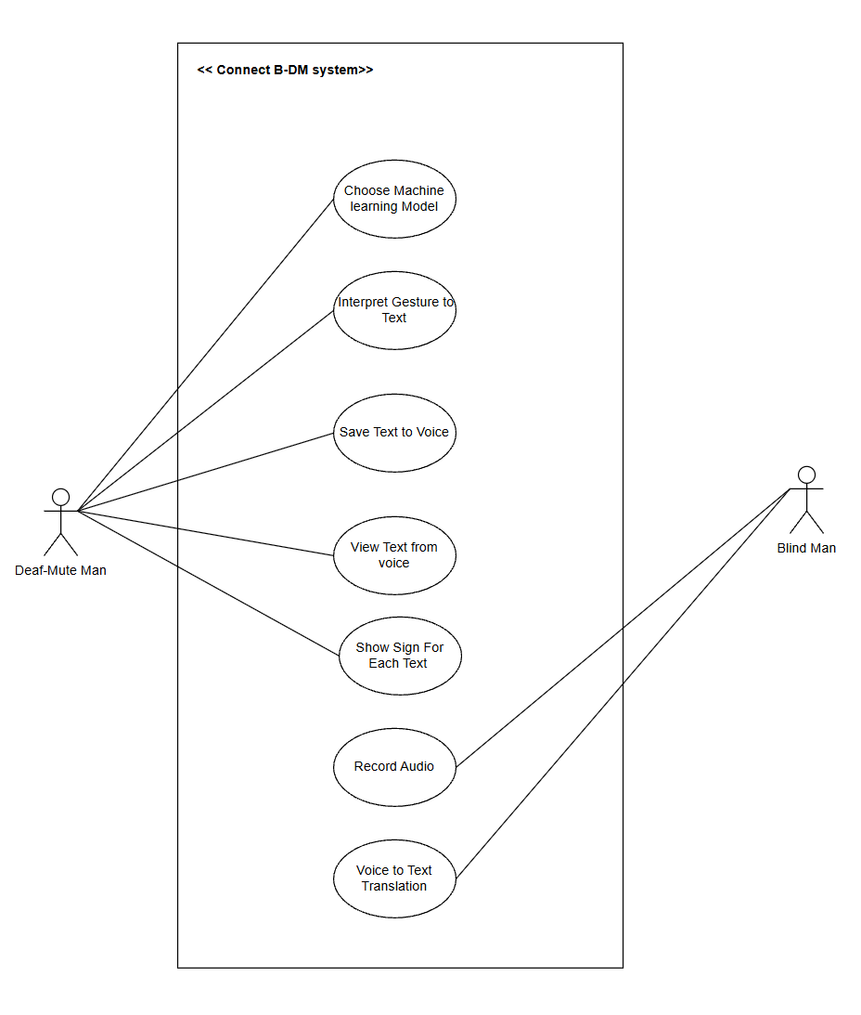
Figure 2: Use case diagram for Connect B-DM
    - Non-Functional Requirements
Non-functional requirements define how the system performs rather than what it does. The key non-functional requirements of the system include:
Performance:
The system should be able to process gestures, voice, and text inputs with minimal delays to support real-time communication.
Accuracy:
The system also should provide reliable speech recognition and gesture interpretation with accuracy under normal operating conditions. Normal operating conditions include environment with proper lightning conditions and less noisy environment for gesture and voice recognition
Usability:
The system should be easy to use and accessible for users with sensory impairments, requiring minimal training effort.
Reliability:
The system also should operate consistently without frequent failures during continuous communication sessions.
Scalability:
The system shall allow future enhancements such as support dynamic gestures, or improved recognition models.
    - Feasibility Analysis
Feasibility analysis is the process of evaluating whether a proposed system is practical and viable before full-scale development. It helps determine whether the project can be implemented successfully within given constraints such as cost, time, technology, and operational capability.
1. Technical Feasibility
The project is technically feasible as it uses Python and well-established technologies such as speech-to-text, text-to-speech, and gesture recognition, all supported by existing libraries and tools. The required hardware (camera, microphone, and display) is commonly available and easy to integrate.
2. Economic Feasibility
The project is cost-effective since it could be completed using existing hardware and software resources. No extra money will be spent for purchasing any new tools or equipment.
3. Operational Feasibility
The system is simple to operate and designed for users with sensory impairments, requiring minimal user interaction and training.
4. Schedule Feasibility
The project can be completed within the allocated time frame as the technologies used are well-documented and development can be carried out in modular phases. Proper planning and resource availability ensure timely completion.

Table 1: Project Schedule Chart of Connect B-DM

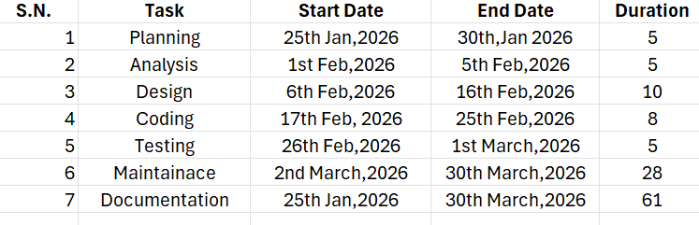
    - Analysis
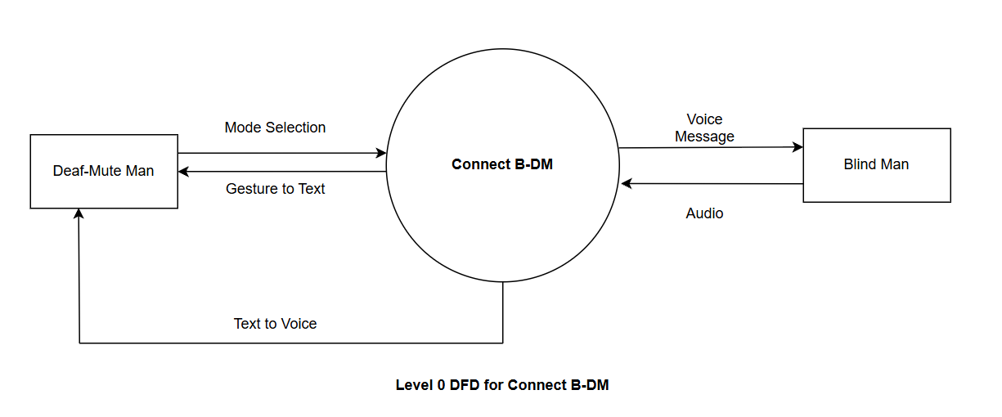
Figure 3: Level 0 DFD of Connect B-DM

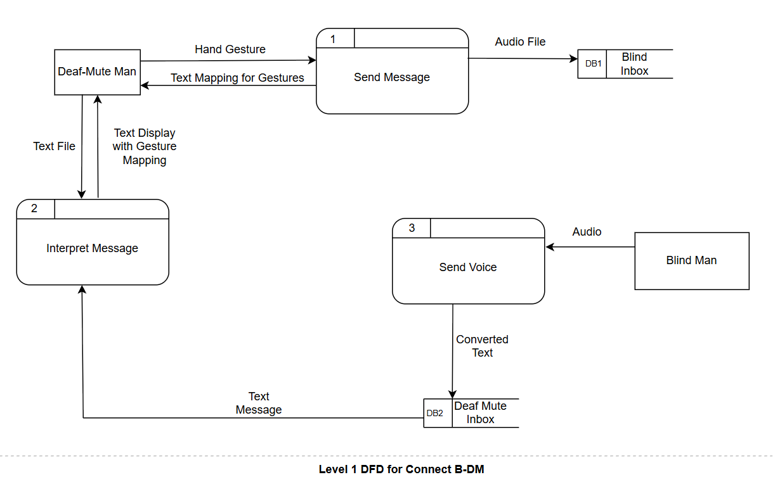
Figure 4: Level 1 DFD of Connect B-DM

SYSTEM DESIGN

Algorithm Details
The main algorithm implemented in this program is demonstrated below.
For Gesture Recognition:
To recognize gestures, currently 2 models have been implemented.
Convolution Neural Network
In this project, a Convolutional Neural Network (CNN) is trained to recognize hand gestures from landmark features extracted from images of sign language. The CNN processes the coordinates of hand landmarks (21 points with x, y, z coordinates, total 63 features per sample) and classifies them into the corresponding sign or letter.
- Input Layer: The 63 landmark features are reshaped into a 21×3 array (21 landmarks × 3 coordinates).
- Convolutional Layers:
- Three 1D convolution layers are used with 64, 128, and 256 filters respectively.
- Each layer uses a kernel size of 3 and ReLU activation to extract spatial patterns from the hand landmarks.
- Batch normalization is applied after each convolution to improve training stability.
- Flatten Layer: Converts the 3D feature maps into a 1D vector for fully connected layers.
- Dense Layers:
- A dense layer with 256 neurons and ReLU activation captures higher-level features.
- Dropout of 0.4 prevents overfitting.
- The final dense layer outputs probabilities for each gesture using softmax activation.
Some hyperparameters information
- Hidden Layers: 3 convolutional layers + 1 fully connected hidden layer.
- Activation Function: ReLU for hidden layers, Softmax for output layer.
- Optimizer: Adam (default learning rate = 0.001)
- Loss Function: Sparse Categorical Crossentropy (for multi-class classification)
- Epochs: 50: Though it may not reach upto 50 because of early stopping concept.
- Batch Size: 64
- Regularization: Dropout (0.4) and batch normalization.
K-Nearest Classification
Implementation steps:
- Load Dataset
- Load landmark features (X) and labels (y) from the pre-processed ASL dataset.
- Normalize the features by dividing by the maximum value to scale all coordinates between 0 and 1.
- Split Data
- Divide the dataset into training (70%) and testing (30%) sets.
- Ensure the split preserves the distribution of each gesture class. Use stratified split.
- Initialize KNN Classifier
- Set the number of neighbors $K=5$.
- Store training data and labels for distance comparisons.
- Prediction (for each test sample):
- Compute the Euclidean distance between the test sample and all training samples:
- $d=\sqrt{∑(x_{\text{test}}-x_{\text{train}})^{2}}$
- Identify the K nearest neighbors (smallest distances).
- Take a majority vote among their labels to predict the class.
- Batch Prediction
- Process test samples in batches (batch size = 100) for efficiency.
- Aggregate predictions for all test samples.
- Evaluation
- Compute the confusion matrix to visualize correct and incorrect classifications.
- Calculate precision, recall, F1-score, and generate a classification report.
- Save Model
- Save the training features, labels, normalization factor, and K value for future use.
- Save the evaluation metrics and confusion matrix for documentation.
Voice Recognition
For voice preprocessing, these algorithms have been used.
Pre-emphasis Filter
It basically boosts high-frequency parts of speech to make consonants clearer and improve speech recognition.
Formula: y[n]=x[n]−α⋅x[n−1]
- $x[n]$→ input audio sample
- $y[n]$→ output pre-emphasized sample
- $α$→ pre-emphasis coefficient (usually 0.95–0.97)
Steps:
- Take the current audio sample $x[n]$.
- Subtract $α$times the previous sample $x[n-1]$from it.
- Repeat this for all samples.
- Keep the first sample unchanged ($y[0]=x[0]$).
Adaptive Noise Estimation for Spectral Subtraction
It removes background noise while preserving speech by dynamically estimating the noise spectrum.
Formula
noise_magt​=β⋅noise_magt−1​+(1−β) ⋅min(frame_mag)
clean_mag=max(frame_mag−noise_mag,0)
Steps:
- Split the audio into overlapping frames.
- Compute the FFT (frequency components) for each frame.
- Estimate noise:
- Initialize using the first few silent frames.
- Update adaptively for each new frame using the formula above.
- Subtract the estimated noise from the frame magnitude.
- Reconstruct the frame using inverse FFT (IFFT).
- Combine all frames to produce the final output signal.
Automatic Gain Control (AGC / Normalization)
It maintains consistent loudness across recordings, making quiet speech louder and very loud speech softer.
Formula:
- Find maximum absolute amplitude:
$$\text{max_val}=max⁡(∣x[n]∣)$$
- Normalize signal:
$$y[n]=\frac{x[n]}{\text{max_val}+ϵ}$$
Steps:
- Find the maximum amplitude of the entire audio signal.
- Divide all audio samples by this maximum value to normalize the volume.
- Optionally, adjust gain dynamically frame by frame using RMS energy for consistent levels.

IMPLEMENTATION AND TESTING

Implementation
The implementation of the project includes following technologies.
    - Tools Used
For coding Visual Studio is used. Hence the following tools are used for front end and backend.
Frontend
Tkinter (Python library for GUI).
Backend
Python libraries:
- Os: to save files, make folders.
- Numpy: for mathematical computations, extract landmark for images.
- Sklearn: for metrics of model like confusion matrix, precision, recall and F1 score. Also, to train, test dataset (can be done manually too).
- Matplotlib’s pyplot module: Just for confusion matrix visualization.
- Mediapipe: hand landmark recognition
- Tensor flow and keras: To train CNN model.
- Pillow: To read images and manipulate it.
- Pyttsx3: For audio manipulation like recording.
    - Implementation Details of Modules
- Main.py file has been created that handles the main GUI interface and connects to different another important python files. Users are provided with 2 buttons to choose respective modes of operations. When the corresponding buttons are pressed it triggers the respective python file as a new process for respective functionality. Libraries like tkinter, threading, os, system has been used here.
- DM2B_CNN.py uses trained CNN models to interpret hand gestures in real time. Similarly, users can also experiment around with another model in DM2B_KNN.py to use KNN as a machine learning model to classify hand gestures.
- InterpretText.py displays responses from blind messages on the GUI screen. However, the voice to text has already been converted into B2DM.py file. In InterpretText.py, libraries like tkinter and pillow are mainly used while in B2DM.py, libraries like pyttsx3 and scipy have been used.
- ProcessASLDataset.py simply processes ASL dataset containing different gesture images and extracts landmark from those images and saves it as np array in a compressed format in .npz file. Libraries like mediapipe has been make use of here to extract hand landmarks.

Testing
Testing is a critical phase to ensure that the system functions correctly and meets user requirements. Various testing methods are applied to verify system reliability, functionality, and performance.
Types of Testing Performed
Unit Testing
Each module of the system was tested independently to verify correctness and stability. For instance:
- Machine Learning Modules: CNN and KNN training modules were tested to ensure proper model initialization, data ingestion, training convergence, and accurate predictions on test samples.
- GUI Modules: Individual GUI components, including buttons, input fields, and display areas, were validated to confirm correct functionality and responsiveness under user interaction.
Integration Testing
Modules were tested collectively to ensure seamless data flow and interaction between different components. Examples include:
- GUI–Backend Interaction: Opening the main GUI and invoking actions through buttons triggered corresponding processing scripts correctly.
- Thread Coordination: Since multiple GUI-driven scripts run concurrently, threading mechanisms were tested to prevent race conditions, deadlocks, and ensure synchronized execution between GUI events and backend processes.
System Testing
The complete system was evaluated for both functional and non-functional requirements:
- Functional testing ensured end-to-end communication between blind and deaf-mute modules, verifying that gesture, text, and voice conversions occurred correctly.
- Performance testing assessed real-time responsiveness, memory utilization, and stability under typical usage scenarios to ensure the system operates reliably as an integrated application.

Result Analysis
The following displays output snapshots of current project.
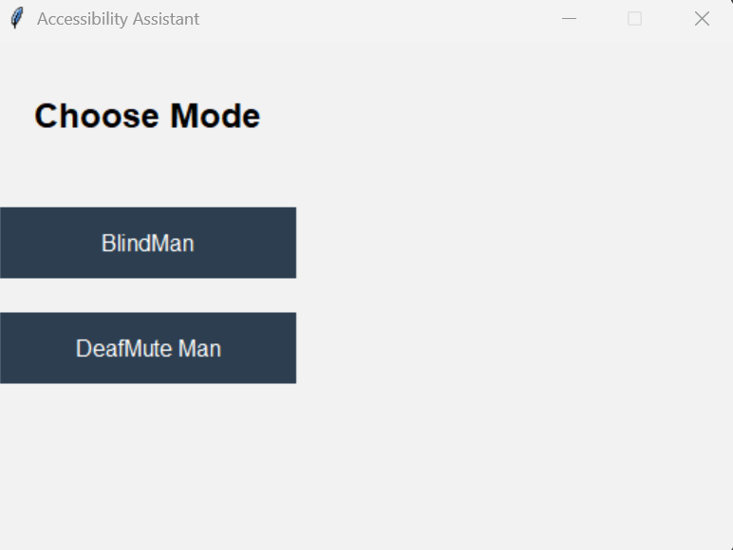
Figure 5: Main GUI Screen
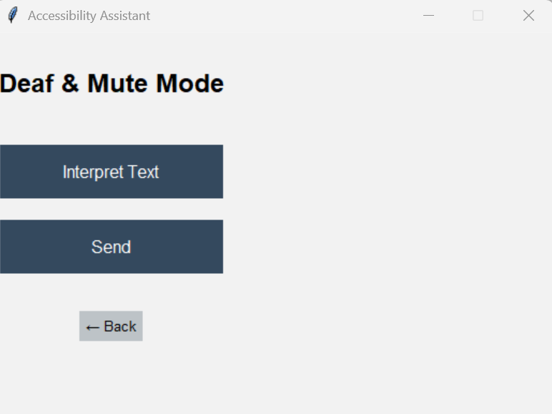
Figure 6: Deaf and Mute Mode
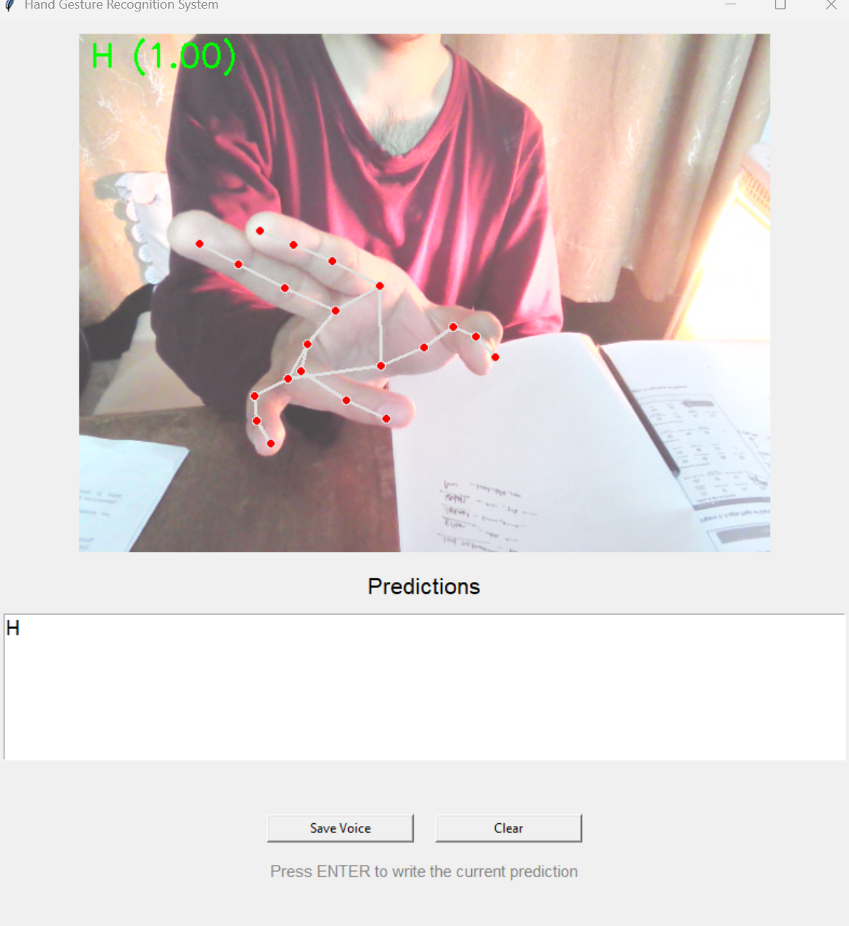
Figure 7: Send Message
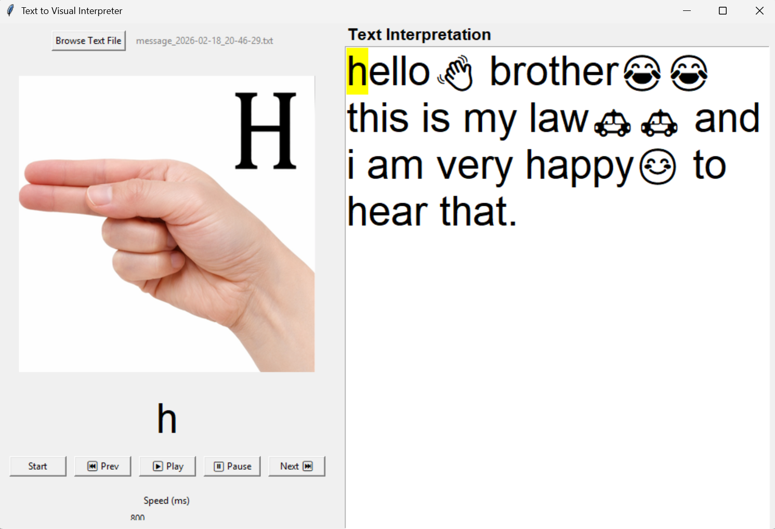
Figure 8: Interpret Text
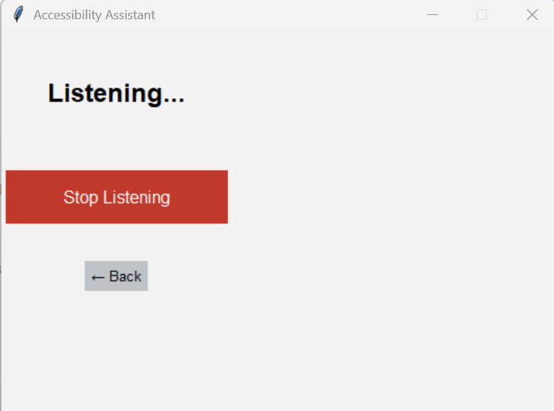
Figure 9: Blind Man's Voice Interface

CONCLUSION AND RECOMMENDATIONS

Conclusion
This project successfully developed an integrated Python-based system enabling real-time communication between blind and deaf-mute users by converting gestures, text, and voice across multiple modalities. The system combines machine learning models, including CNN and KNN, with speech and gesture processing techniques to ensure accurate and responsive interactions. Thorough testing at the unit, integration, and system levels confirmed the reliability, usability, and performance of the solution. Overall, the project demonstrates how modern assistive technologies can effectively bridge communication gaps, enhancing accessibility and independence for individuals with sensory impairments.

Future Recommendations
- Even more variety of models can be used to test its accuracy. For example: Decision Tree and Random Forest model.
- GUI can be made more user friendly.
- More natural way of interpreting text to deaf-mute man can be tried.

REFERENCES
[1]. K. Manikandan, A. Patidar, P. Walia, and A. Barman Roy, “Hand Gesture Detection and Conversion to Speech and Text,” arXiv preprint arXiv:1811.08781, 2018.
[2]. R. Kumar, A. Bajpai, and A. Sinha, “Mediapipe and CNNs for Real-Time ASL Gesture Recognition,” arXiv preprint arXiv:2305.05296, 2023.
[3]. A. P. Neog, A. Kalita, and N. Pandiyarajan, “Speech/Text to Indian Sign Language Using Natural Language Processing,” Indian Journal of Computer Science and Engineering (IJCSE), vol. 14, no. 3, pp. 551–560, May–Jun. 2023.

